CITY OF BARTOW
ORGANIZATION FUNDING REQUEST APPLICATION
Not for Profits, Tax Exempt Entities and Community-Based Organizations Only
Deadline to submit request is June 16, 2025.
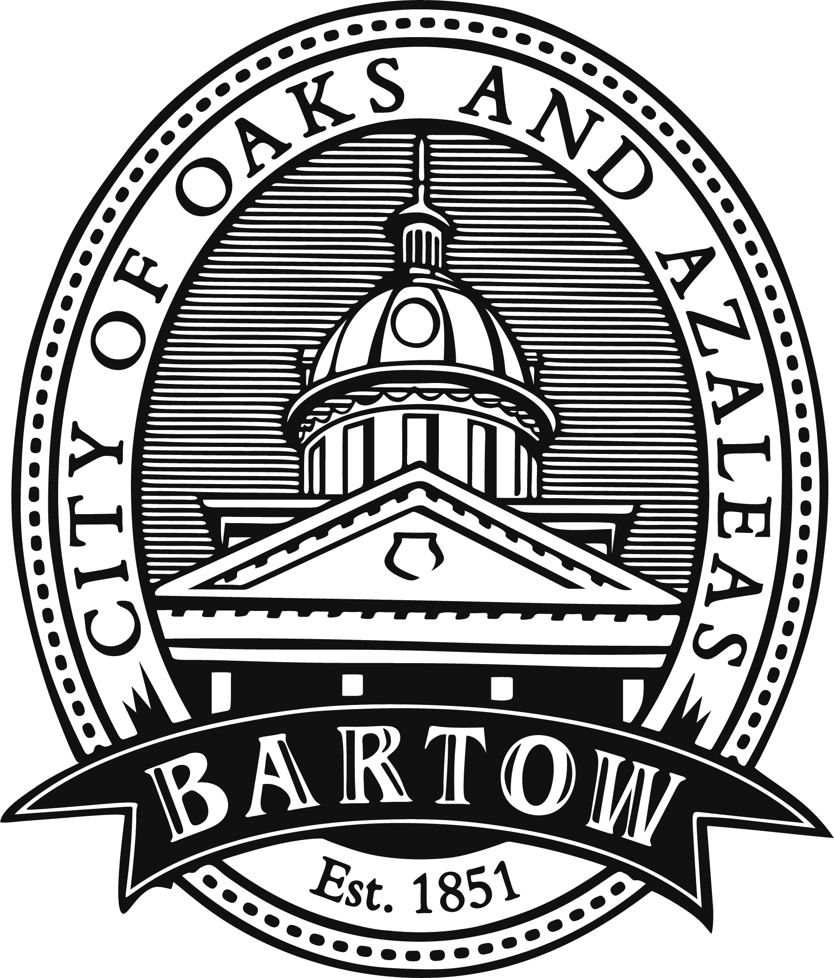
Name of organization | Click or tap here to enter text.
Type of organization | Click or tap here to enter text.
Physical addresses | Click or tap here to enter text.
Mailing address | Click or tap here to enter text.
Name and title of administrator | Click or tap here to enter text.
Phone number & email address | Click or tap here to enter text.
Date organization established | Click or tap here to enter text.
Florida Department of State Registration No. | Click or tap here to enter text.
Federal Employer Identification No. (FEIN) | Click or tap here to enter text.
Amount requested | Click or tap here to enter text.
Project budget | Click or tap here to enter text.
Name, phone number and email address of project manager | Click or tap here to enter text.
Organization’s Mission Statement | Click or tap here to enter text.
Who does your organization serve | Click or tap here to enter text.
What category(ies) does your organization best function. Check all that apply. | ☐ Childcare ☐ Cultural ☐ Drug Abuse Counseling or Treatment ☐ Educational ☐ Environmental ☐ Economic ☐ Historical ☐ Homelessness ☐ Housing ☐ Neighborhood ☐ Public Safety ☐Recreation ☐ Senior Citizens Services ☐ Special Needs [physical or mentally challenged] ☐ Youth Mentoring
Project summary | Click or tap here to enter text.
Projected start and completion dates (must be within the City’s fiscal year) | Click or tap here to enter text.
Describe the project’s objective | Click or tap here to enter text.
How will the funds be utilized | Click or tap here to enter text.
What will the funds help your organization accomplish | Click or tap here to enter text.
Who is your target population | Click or tap here to enter text.
What impact will the requested funds have on the community | Click or tap here to enter text.
How do you plan to promote the opportunity affiliated with the funds | Click or tap here to enter text.
What other organizations are you seeking funding from for this project | Click or tap here to enter text.
Does your organization currently receive funding from other agencies? If the answer is yes, list who it is from, and the amount received | Click or tap here to enter text.
What other agencies is your organization affiliated with | Click or tap here to enter text.
Name and title of person making application | Click or tap here to enter text.
Signature of person making application |  |  | Date: | Click or tap here to enter text.
CERTIFICATION BY AUTHORIZED ORGANIZATION OFFICAL: By signing the foregoing application, attests that I have examined the information included in the application and hereby certify that, to the best of my knowledge and belief that the contents are true, accurate and complete.
Name & title of authorized organization official |  | Click or tap here to enter text.
Signature of authorized organization official |  |  | Date: | Click or tap here to enter text.
SUBMIT APPLICATIONS WITH A COPY THE ORGANIZATION’S
ADOPTED BUDGET, BYLAWS AND STATE AND FEDERAL ID NUMBERS.

CITY OF BARTOW - CITY CLERK’S OFFICE
450 N. WILSON AVENUE
BARTOW, FL 33830
or by email to jpoole.clerks@cityofbartow.net
Deadline to submit request is June 16, 2025.

Should your organization receive a City of Bartow grant, the following will be required:
- Sponsorship statement and City logo placed on promotional pieces the grant money affects.
- Submission of electronic photographs, when appropriate, of the grant investment use.
- If you have received a grant in the prior year a progress report is to be submitted with your application. That report will describe how the funds were utilized, and a summary of the impact made on the people served. New organizations submitting an application are exempt from provide a progress report.

