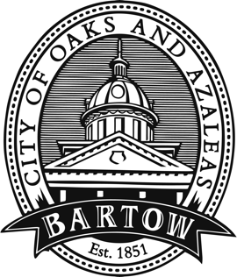
CITY OF BARTOW
450 N Wilson Ave.
Bartow, FL 33830
CityofBartow.net

PRESS RELEASE
For immediate release
Contact: Laurie Hayes, Director of Communications
lhayes@cityofbartow.net
Office: 863.733.4642
Cell: 863.378.7929

City of Bartow Government to Close at noon on Tuesday

(October 7, 2024 – Bartow, FL) Due to approach of Hurricane Milton, the City of Bartow Government will close all City facilities including City Hall, the Public Library, Carver and Polk Street Recreation Centers and the Civic Center at noon on Tuesday, Oct. 8. The Bartow Golf Course and Mulligans Bar & Grill will be closed Tuesday and remain closed until further notice. The reinstatement of City government operations at City Hall will be evaluated on Thursday, Oct. 10. All other facilities will be assessed on Friday, October 11, with reopening information shared as soon as possible.

Rentals at the Civic Center, Carver Recreation Center, and Polk Street Community Center are cancelled through Monday, October 14. The availability of those facilities for rentals and meetings that take place October 15 - 20 will be reassessed next week.

Solid Waste service will continue tomorrow and Wednesday as weather conditions allow. Thursday residential trash and recycling services will be moved to Saturday. Residents should bring waste containers in from the curb by Wednesday evening and secure these and any other loose items on your property. At this time, Tuesday and Friday residential pick-up will be as normal.

Residents should refrain from placing additional bulk items or yard waste at the curb for pick-up. Crews will be out collecting existing items pre-storm. Thursday commercial pick-up will occur on Friday and Friday’s commercial pick-up will move to Saturday. Questions regarding solid waste should be directed to 863.534.0181 or email solidwaste@cityofbartow.net.

City of Bartow Customer Service has suspended working Service Orders such as Service Initiations, Service Terminates, etc.

Police, Fire, Public Works, Electric, Water and Wastewater will continue to provide all essential services as directed in the city’s emergency management protocols. Residents are cautioned that rescue services may be hampered by severe weather conditions.

Bartow residents are advised to take all necessary precautions to prepare their property and families for the hurricane, prior to the arrival of the storm. Once conditions worsen, residents are urged to shelter in place and avoid travel as much as possible to ensure their safety and the safety of first responders who must be on the roads. Polk County has opened shelters for those whose homes may be at risk from flooding or wind. A complete list of shelters is available at www.polk-county.net/news/polk-county-shelters-to-open/

Questions or requests for non-emergency assistance before and after the storm should be directed to 863.534.5034.

###

