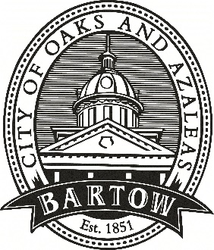
CITY OF BARTOW
450 N Wilson Ave.
Bartow, FL 33830
CityofBartow.net

PRESS RELEASE
For immediate release
Contact: Laurie Hayes, Director of Communications
City of Bartow
lhayes@cityofbartow.net
Office: 863.534.0100, ext. 1205
Cell: 863.378.7929

Bartow City Manager Mike Herr appointed to
National League of Cities Transportation Committee

(January 18, 2024 – Bartow, FL) Bartow City Manager Mike Herr has been appointed to the National League of Cities’ (NLC) 2024 Transportation and Infrastructure Services (TIS) Federal Advocacy Committee. The TIS Committee is responsible for leading NLC’s policy development and advocacy on transportation for communities of all sizes.
“I am honored to join the officers and members of this important group to further the goals of the National League of Cities,” said Herr. “Municipalities across the country benefit from this and other efforts of the League.”
Herr was elected to a one-year term and will provide strategic direction and guidance for the NLC’s federal advocacy agenda and policy priorities on transportation and infrastructure. The appointment was announced by NLC President Mayor David Sander of Rancho Cordova, CA.
As a member of the TIS Committee, Herr will play a key role in advocating for federal funding opportunities for cities and towns, improving safety and connectivity, and leveraging innovation for all types of transportation. With the passage of historic bipartisan federal infrastructure programs, TIS is focused on the intergovernmental partnership needed to utilize direct competitive federal transportation programs, improve safety on our roads and sidewalks, and enhance the connectivity of regions with shared rail, transit and aviation options.
“NLC’s federal advocacy committees play an important role in helping policymakers in Washington understand the issues and challenges facing America’s cities, towns and villages at the local level,” said Mayor Sander. “I’m thrilled to have Mike serve on NLC’s Transportation and Infrastructure Services Committee this year and look forward to working with him to strengthen the federal-local partnership and grow our common knowledge of the issues and opportunities facing our communities.”
“As the County seat located near several major thoroughfares, Bartow has many challenges with regards to transportation,” noted Herr. “I look forward to working with my colleagues from across the county as well as state and federal representatives to ensure that Bartow, and municipalities across the nation, receive the funding necessary to ensure safe, reliable, affordable and innovative transportations options within our boundaries and beyond.”
###

