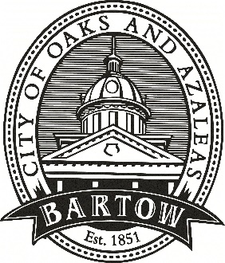
CITY OF BARTOW
450 N Wilson Ave.
Bartow, FL 33830
CityofBartow.net

PRESS RELEASE
For immediate release
Contact: Laurie Hayes, Director of Communications
City of Bartow
lhayes@cityofbartow.net
Office: 863.534.0100, ext. 1205
Cell: 863.378.7929

Bartow City Manager Mike Herr Honored with
2024 Home Rule Hero Award
Herr recognized for advocacy efforts during the 2024 Legislative Session
(March 15, 2024 – Bartow, FL) Bartow City Manager Mike Herr has been awarded a 2024 Home Rule Hero Award from the Florida League of Cities (FLC) for his hard work and advocacy during the 2024 Legislative Session. FLC, the united voice for Florida’s municipal governments, recognized Herr for his efforts throughout session to promote local voices making local choices, protect the Home Rule powers of Florida’s municipalities and advance the League’s legislative agenda.
“The dedication and effort of these local officials who tirelessly advocated for local decision making was a difference maker this legislative session,” said FLC Chief of Legislative Affairs Casey Cook. “On behalf of the League and its legislative team, we’re proud to recognize each of them and thank them for their service.”
Home Rule is the ability for a city to address local problems with local solutions with minimal state interference. Home Rule Hero Award recipients are local government officials, both elected and non-elected, who consistently responded to the League’s request to reach out to members of the Legislature and help give a local perspective on an issue.
“I am honored to be chosen as a Home Rule Hero,” said Herr. “I have long been a champion of Home Rule in Florida and look forward to working with our state and federal representatives in upcoming sessions to ensure that local self-government continues to thrive here.”

Herr, a long-time public servant, has served as Bartow’s City Manager since January 2023. He previously was the City Manager in Winter Haven and in Plant City as well as Polk County Manager, among other high level municipal positions. Herr also serves on FLC’s 2023-2024 Advocacy Committee and its Federal Actions Strike Team, as well as on the National League of Cities’ 2024 Transportation and Infrastructure Services Federal Advocacy Committee.

###

