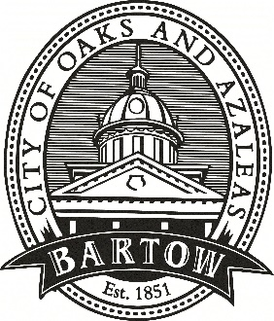
CITY OF BARTOW
450 N Wilson Ave.
Bartow, FL 33830
CityofBartow.net

PRESS RELEASE
For immediate release
Contact: Laurie Hayes, Director of Communications
City of Bartow
lhayes@cityofbartow.net
Office: 863.534.0100, ext. 1205
Cell: 863.378.7929

Bartow Mayor, Vice Mayor Named FLC 2024 Home Rule Heroes

(March 19, 2024 – Bartow, FL) City of Bartow Mayor Leo Longworth and Vice Mayor Trish Pfeiffer have been honored as 2024 Home Rule Heroes by the Florida League of Cities (FLC) for their hard work and advocacy during the 2024 Legislative Session. FLC, the united voice for Florida’s municipal governments, recognized Longworth and Pfeiffer for their efforts throughout session to promote local voices making local choices, protect the Home Rule powers of Florida’s municipalities and advance the League’s legislative agenda.
Home Rule is the ability for a city to address local problems with local solutions with minimal state interference. Home Rule Hero Award recipients are local government officials, both elected and non-elected, who consistently responded to the League’s request to reach out to members of the Legislature and help give a local perspective on an issue.
Noted Mayor Longworth, “I value the importance for us to continually advocate for our cities and to always remember that ‘We Live Local.’”
“The dedication and effort of these local officials who tirelessly advocated for local decision making was a difference maker this legislative session,” said FLC Chief of Legislative Affairs Casey Cook. “On behalf of the League and its legislative team, we’re proud to recognize each of them and thank them for their service.”
“I am happy to be a part of the Legislative process with the Florida League of Cities advocating for Home Rule protections and supporting legislative bills and appropriates for our city,” added Vice Mayor Pfeiffer.
Bartow City Manager Mike Herr was also recognized as a Home Rule Hero by the League.
###

